About the data analysis
What follows is my initial take on the data analysis for within each class. This project benefits from having large numbers of sentient beings involved, so please don’t feel bound by my suggestions. You may want to ask the same questions in a somewhat different way, or you may have thought of new questions you want to ask that aren’t covered in this protocol. At this point (each class analyzing their own data) we definitely benefit from diversity, so feel free to consider this document as a starting point.
I’ve divided the data analysis into two components – exploratory data analysis and hypothesis testing/model comparisons. The first component entails examining the data for errors and outliers, graphing the data, and getting a general sense of the relationships among variables. The second attempts to answer the three main questions we posed at the outset of this project. It may be worth having a quick reminder of those now:
1) Over what spatial scales do landscape variables have their maximum effects on frog presence/absence and species richness?
2) Do some specific types of roads (e.g. primary/secondary) adversely affect frogs more than others?
3) Do frog populations appear to respond to the connectivity of nearby habitats? And if so, do they respond to upland (e.g. forest) connectivity or just wetland connectivity?
I give the instructions below for doing the analyses in the R statistical package. If you’d rather use some other package that you are more familiar with (e.g. SAS, SPSS, Stata, Systat, etc.), feel free to do so. The script file containing the commands below is “MOexplore.txt”. You can just open this file and run the commands from there.
Exploratory data analysis – background and motivation
Typically, before one begins testing the major questions/hypothesis for a research project, one does some exploratory data analysis. Exploratory data analysis usually involves graphing some or all of the variables of interest and examining which variables seem to be associated with which other variables. This is not a fishing expedition for interesting results – major findings from any study should be based on questions you came up with before you started the analysis (see above). Rather, exploratory data analysis has a few specific goals.
First, by graphing results, one can detect outliers in the data. Outliers might contain important information, but they also might reflect errors in data entry. It could be easy to miss a stop with species richness of, say, 88 when just scanning the column of numbers. But if you make a graph of species richness relative to any other variable, this value (which almost certainly must have been mis-entered) will pop right out. If you were to note a species richness of 22 (instead of 88), you wouldn’t automatically know that this value was incorrect, but it would definitely be something you would want to go back and check. Just a few errors like this can really throw off a data analysis, so graphing your results and checking for outliers is a very important step.
Second, graphing results can give you a good idea of the most apparent results of a study. This may be your first exposure to many of the statistical methods that you’ll find in this protocol, and some of these could reasonably be considered “complicated.” But ultimately, most results that will show up in a statistical analysis should be visible in an appropriate plot of the data.
Third, looking at relationships (e.g. correlations) among variables can also give you information that you would want before doing your final data analysis. If you haven’t worked with correlations before, here’s some basic background. Correlations between variables always range from -1 to 1. A correlation of 1 means that two variables are completely associated – so that with an incremental increase or decrease in one variable you would get an exactly proportional increase or decrease in the other. A correlation of -1 means that with an increase in one variable you would get an exactly proportional decrease in the other variable. And a correlation of 0 means that two variables aren’t associated at all, so that knowing that one variable is relatively high or low tells you nothing at all about the value of the other variable.
If the correlation between two variables is very high (e.g. 0.8 or 0.9) then we can’t really expect to be able to differentiate their effects. For example, imagine that Road Length is highly correlated with Proportion Developed (this wouldn’t be all that surprising). If sites with high road lengths and high development always have low amphibian richness there’s no statistical magic that can tell us which of these two variables is more likely to be driving the relationship. Similarly, consider two variables like proportion forested and proportion agriculture. These variables have to be negatively correlated, because more land in forest will always mean less land in agriculture. But if this correlation is very strong (e.g. -0.8) then there won’t be much we can do to distinguish the effects of, say high agricultural density from the effects of low forest cover.
It should be somewhat intuitive that very high correlations (e.g.0.8 or 0.9) do not allow one to separate the effects of the different variables. But more likely, we’ll see more moderate correlations in the range of say 0.3 to 0.7 (or -0.3 to -0.7). In this range, it can be hard to know exactly how well we’ll be able to separate out the influence of two variables – it really depends on the specific data points we are analyzing. With moderate correlations, we want to be aware of the correlations so that we know what to pay attention to later in terms of our ability to distinguish the effects of the different variables.
The following sections will show you how to plot the data and examine correlations among the variables using the R statistical programming language.
Getting started with R.
You’ll first need to download R. R is free, open-source, and works well in either a windows or mac environment. You can download R for mac and windows by following the instructions at:
http://www.r-project.org/
Second, I’d strongly suggest that you also download a User Interface for R called RStudio. RStudio makes it much easier to do things like import data, install stats packages and export graphs. You can get R studio from https://www.rstudio.com/ Just click on “Download Now.”
Once you’ve downloaded RStudio, you can just open it and it should be able to find and work with the previously installed version of R. Your RStudio window should look like this:
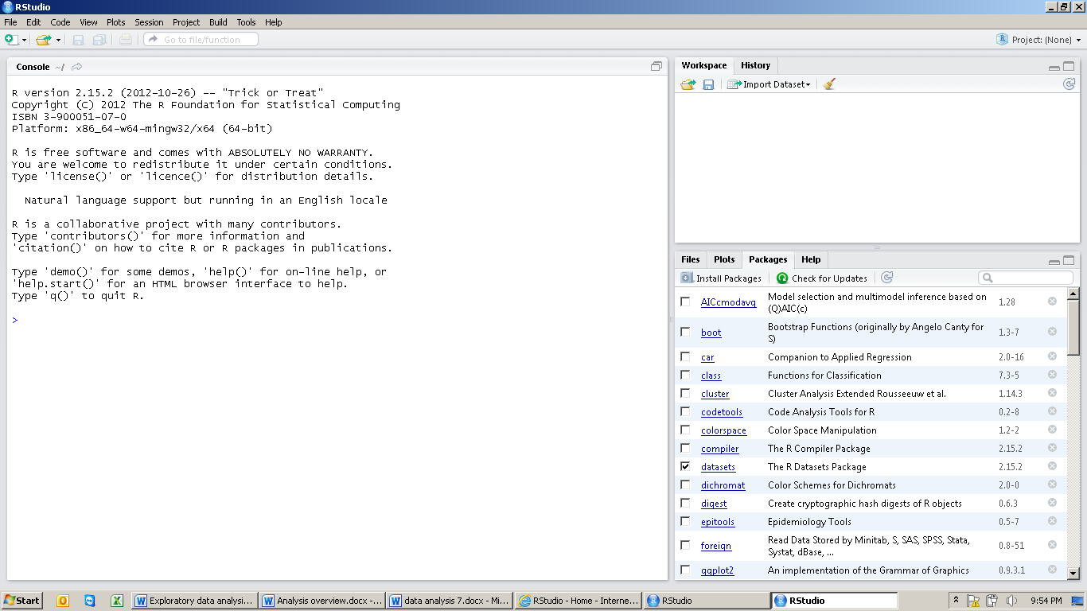
The window at the left is the “console” where commands are entered. At the upper right is the workspace where you can import datasets and see what data and data objects are currently available. At the lower right is a list of all the available packages and a tab for installing additional packages.
Rather than entering commands directly into the console, it’s usually preferable to run commands from a script (program) that you write as you go. That way, if you need to rerun any part of the analysis you can just use the existing script – you won’t have to re-enter any commands. You can open a script window at the top left by going to File then New then R Script. Now, your RStudio window will look like this:
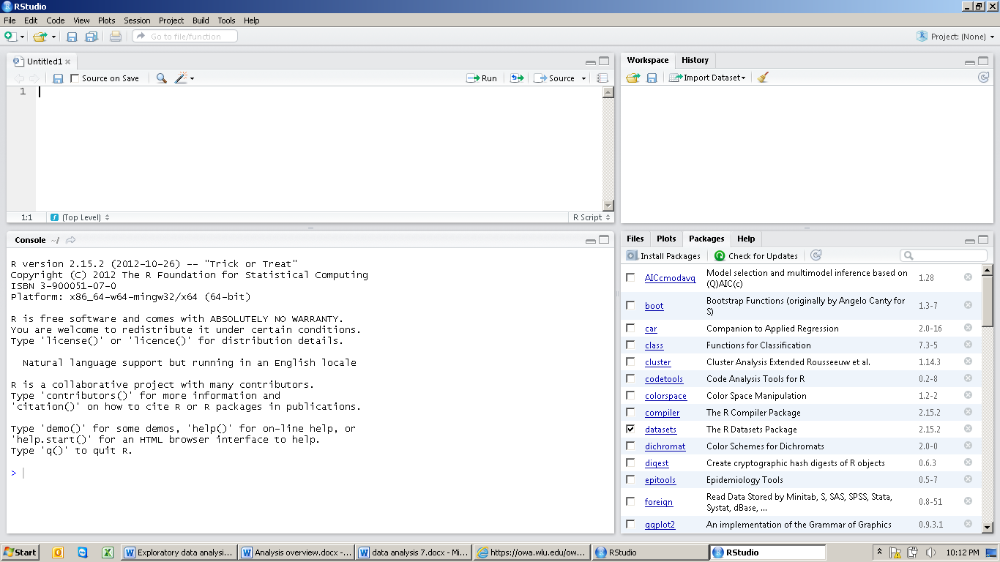
Where to go for help
In R, you can get information/help on a function by typing ?(function) into the command line (>)
For example, if you type
?cor
You would get help with syntax for the correlation function.
For general help with basic tasks in R, I often use the QuickR website: http://www.statmethods.net/
Formatting your data
Most of the trick with any analysis is just getting the data into the correct format. You’ll likely want to get some issues in order with your class’ data before you attempt to import them into R.
1) Make sure there are no spaces in the column headings – there shouldn’t be if you’ve just copied them in from the template.
2) Make sure there are no units, asterisks, or other text embedded with numerical data. For example, if a road length is 12000, the cell should just say 12000, not 12000m or 12000*.
3) Replace all empty cells (or other text indicating missing data) within your spreadsheet with “NA” . That’s the standard R syntax for missing data, so it should be understood by all R functions. You can replace spaces with NA efficiently using the find/replace function in Excel (or Google spreadsheet).
4) Take out unnecessary text columns. I’m thinking specifically about the Notes columns here. Don’t delete those from the face of the earth obviously, just trim them from the working analysis spreadsheet. These would cause formatting nightmares for R.
5) R (as with most statistical software) is case sensitive. So, NA is different from Na or na. This is a common problem if multiple people have entered data into the final datasheet.
The protocol is based on a working spreadsheet draft from Missouri (“MOtest.txt”). This contains a combination of real and made-up data from MO – feel free to have a look at it for formatting tips.
Importing your data into R
In RStudio, you can import your data from the Import Dataset tab in the upper right window. Just make sure that Heading = yes to tell R that the first row is the variable names.
For some additional proofreading, it’s generally useful to get a data summary using the “summary” command:
>summary(MOtest)
Min and max are useful to look at to check for obvious errors. Also, sometimes you will find numerical variables that R has interpreted as categories and so you will see tallies for each value rather than means and medians. You’ll notice in this case that the only variable with NAs is WET_CONNECT since this was recorded only for the 10000m scale.
Merging and formatting your data
OK, so I didn’t necessarily think carefully enough when I put together the landscape template. Really, we probably want things like WET_AREA within 300m, 600m, 1000m, etc to each have their own column because this will make it easier to compare these variables to one another.
Fortunately, there’s a relatively easy fix for this using an R package for data management called “reshape.” This can be installed by clicking on Install Packages in the lower right Packages window and then typing in “reshape.” There’s also a “reshape2” which may work fine but I haven’t yet tried it. Anyway, once you’ve installed make sure it’s checked as loaded (packages need to be loaded before they can be used, even if they’re already been installed).
Here’s the code for reshaping the dataset (note, #indicates that whatever follows is an internal code and is not read into code). You can copy and paste it into a script window, then highlight it and click Run.
library(reshape) #loads the reshape package

# "melt' the MOtest data using "reshape" package then cast it in the correct format
MO2<-melt(MOtest, id=c("route", "stop", "SiteID", "ENTERED.BY", "BUFFER.SIZE"))
MO3<-cast(MO2, route + stop + SiteID + ENTERED.BY ~ variable + BUFFER.SIZE)
#convert the resulting array to a data frame
MOland<-as.data.frame(MO3)

You can type in
summary(MOland)

to see what you’ve now created (or you can just view the dataset in the upper left window). The result of all this is a new dataset called MOland (for Missouri landscape) that has one row for each NAAMP stop and then has each distance buffer as a different column. The columns for WET_CONNECT are all NA except for those at 10,000m because this is the only buffer we used for this variable.

Creating a correlation matrix for the data

Since I have all these variables together now, it’s not a bad time to look at correlations among them. Correlations only work for numerical variables (i.e not route or SiteID), so I’ll first create a new dataset that drops these first four columns and then does correlations among all the remaining columns. This would be:
# look at correlations among the various landscape variables.
MOcordata<-MOland[5:49] #pulls out just the numerical variables to create a correlation matrix
MOcors<-cor(MOcordata, use="pairwise.complete.obs") #correlations of all variables

This generates an error message because of the NAs in the WET_CONNECT columns, but it does all the other variables. The result is in the matrix MOcors, which you can scroll through the look at the correlations. Most of the high correlations in here are predictable (e.g. the same variable measured at different scales) but it’s definitely worth taking note of what stands out. For example, the correlation between PROP_FOR_1000 and PROP_FOR_5000 is 0.98, which means there’s probably no way to distinguish between forest effects on these two scales. Actually, in general, the correlation among PROP_FOR measurements was quite high in MO, presumably because either sites are in large forest tracts or they are not.

You can also do correlations among single pairs of variables. First you need to “attach” the dataset so that R knows which data set you want to look at. Then, you specify the two variables of interest.
attach(MOland)
cor(PROP_DEV_300, PROP_DEV_1000, use="pairwise.complete.obs")

Merging the two datasets
Next step is to merge the landscape data with the frog call summary data. This dataset is saved as “summaryMO.csv”. So I import this data set just like the other. Then, once it’s entered, I add a command to merge these together:
MOcombined<-merge(MOland, summaryMO, by ="SiteID")
This creates another dataset called MOcombined that combines the two of these according to the SiteID (i.e. it puts data together for the same SiteID. The merge command carries out what is known as an “inner join”, meaning that any sites that aren’t in both original datasets are dropped. In the MOset, everything matched up so the final dataset has the same number of rows (70) as the initial dataset.
Once again, I’d suggest doing summary(MOcombined) to make sure you’ve got what you think you should have here.
Plotting your data.
Now that you have all your data together in a good format, you can begin by plotting some data. This is useful to detect outliers, errors in data entry, and strange patterns that might indicate problems with the data. I won’t go into graphics in depth, and honestly, I typically use other graphics programs to generate high quality graphs. But you can really do what you need to do for plotting with a couple of simple functions.
First, you’ll have to tell R which dataset to use to find your data (since you have a bunch of them now) – this uses the attach function:
attach(MOcombined)
Now you can do some simple plots of your data. For example, you might want to looks at T_ROAD_LEN (total road length) relative to PROP_DEV (proportion developed) at say 1000m. This would just be:
plot(T_ROAD_LEN_1000, PROP_DEV_1000)
If you’ve done this correctly, a scatterplot will pop up in the window at the lower right. If you get an error, it’s probably that you haven’t correctly typed the names of the variables – for example “road_len” instead of “ROAD_LEN”.
With the test data (MOcombined), I don’t really see anything that alarms me on the graph. There is one value for PROP_DEV that stands out, but this is still only about 30% developed, which doesn’t seems strange. With road length, the largest value corresponds to this same site, which makes sense. If there were one point way out by itself (e.g. much greater road length than any other site), I’d be inclined to go back and check that data point.
To do more like, it’s probably easiest to just copy and paste the command into the script and change the details, e.g.:
plot(T_ROAD_LEN_5000, PROP_DEV_5000)
Some other plots you might want to try for data proofing are, the relationship between forest and agriculture, the relationship between the different road classes (e.g. O,P, and S) and relationships between connectivity and wetland area at the smaller scales (this is a good way to look for possible mistakes in wetland connectivity calculations).
Relationships between richness and the total number of surveys (Num.Surveys) are important to look at because they potentially tell us about the value of data from sites where only a few surveys were done.
Can you look at this with:
plot(Num.Surveys, richness)
cor(Num.Surveys, richness, use="pairwise.complete.obs")
You can see that sites with only a few surveys tended to pick up only a few species. Looking at this, I might be included to disregard sites with fewer than about 8 surveys from further analyses. You could do this with the subset command:
MOcomb8<-subset(MOcombined, Num.Surveys>7)
attach(MOcomb8)
cor(Num.Surveys, richness, use="pairwise.complete.obs")

The correlation has gone down from 0.54 to 0.27, which is definitely an improvement though it doesn’t entirely solve the problem (more about this later).

If you want to play around with the data a bit, you can do some other kinds of plots. For example, a scatterplot with a regression line would look something like this:
#plot with a regression line
plot(PROP_FOR_1000~PROP_AGR_1000)
abline(lm(PROP_FOR_1000~PROP_AGR_1000))

Here is “lm” is for linear model, i.e. a linear regression.
If you want to do histograms of single variables (also very good for finding outliers), you can use a hist command.
hist (WET_AREA_300)
Indeed, this turns up one value that is more than twice the next highest value. That’s definitely one that should be checked by pulling up the map for this site – it might just be a big lake or something, but I would want to be sure.
Anyway, that’s the basic idea. Typically, I like to look at least one variable relative to at least one other variable that it might be related to. This gives a general picture of what the data look like and what the outliers are.
Happy exploring!

